Installing IBM Informix 14.10

This section discusses the new way to install [IBM Informix 14.10](https://www.ibm.com/products/informix). Traditionally users would download the software from IBM’s Passport Advantage website and or from IBM’s Fix Central website if they want a fix pack. IBM’s Passport Advantage website authenticates users and based on entitlements allowed for your organization, it will show a list of entitled products from which you can choose the needed software binary. A similar mechanism allows for downloads of fix packs from the IBM’s Fix Central website.

**Background**

Typical installation of IBM Informix product is done by unpacking the downloaded binary and then executing a program named “ids_install”. This program walks you through the licensing terms, asks a couple of questions like which location to install the product and if you want to configure and start up an instance at the end of the install.

With IBM Informix 14.10 version things are changing on the way one installs IBM Informix software. A default installation (like you have always done so in the past) will only install the IBM Informix 14.10 Developer Edition. There are additional steps to follow to install the appropriate version needed for your organization’s needs. Let’s see in detail what are the steps that are required to install the correct edition of IBM Informix 14.10

**Editions of IBM Informix 14.10**

To understand the correct method of installing IBM Informix 14.10, it is necessary to understand the various editions that are available. The following shows the list of the editions available:

* IBM Informix 14.10. Developer Edition
* IBM Informix 14.10 Advanced Developer Edition
* IBM Informix 14.10 Time Limited Enterprise Edition
* IBM Informix 14.10 Advanced Time Limited Enterprise Edition
* IBM Informix 14.10 Express Edition
* IBM Informix 14.10 Workgroup Edition
* IBM Informix 14.10 Innovator Edition
* IBM Informix 14.10 Enterprise Edition
* IBM Informix 14.10 Advanced Enterprise Edition

The specific details of the editions and the features supported on each edition is beyond the scope of this blog. We will however discuss the additional steps required to install the correct edition for your organization’s need.

**Download and Unpacking**

Typically, you would go to [IBM Passport Advantage](https://www.ibm.com/software/passportadvantage/pao_customer.html)  website or to [IBM Fix Central](https://www-945.ibm.com/support/fixcentral/) website to download the software binary (in this case IBM Informix 14.10).

It is possible that you now have 3 files after you download the software. A tar file that contains IBM Informix 14.10 binaries, A zip file that can be used during the installation process or after the installation process and another tar file that contains the Client Software Development Kit version 14.10. This is one change that you should notice with IBM Informix version 14.10. The CSDK product is separately made available and is not part of the IBM Informix 14.10 Software bundle.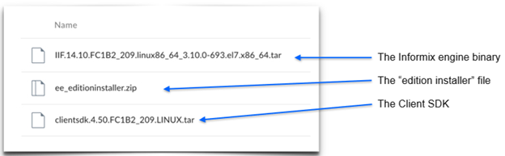

Once you have downloaded the binary and staged it on the appropriate server where the product is to be installed, the next step is to use the unpack the software binary (Depending on the OS platform you would use tar / unzip or some such utility). After you have unpacked the software you should see the following files in your staging area.  
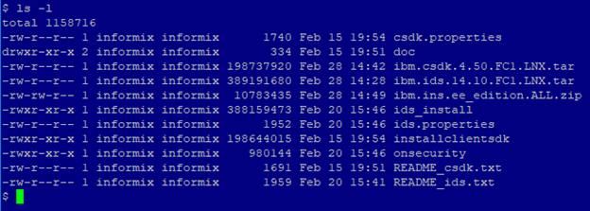

Notice that there are 2 tar files (which have been unpacked) and a zip file.

**Installing IBM Informix 14.10**

With this new release of IBM Informix 14.10, the installation process has been modified to have better flexibility in installing the needed edition. A default installation just by executing the “ids_install” program will only install the Developer Edition of IBM Informix 14.10 database server. This is a notable difference as how the product gets installed.  To install the required or intended edition, you would need to use the zip file that came along with the product.

There are a couple of ways to install the required edition. You can choose to first install the Developer Edition and then run the edition installer program to suitably modify your installation from a Developer Edtion to Enterprise Edition if that is what you want eventually.

Alternatively, by unpacking the edition installer zip file and then executing the “ids_install” program, will install the required edition of IBM Informix 14.10 database server. In other words, the “ids_install” program will look for the jar file specific for the edition and use that to install the required licensed edition of IBM Informix 14.10.

**Two Step Installation**

Below we have shown both approaches towards installing IBM Informix 14.10 with the help of the screen shots. Pay attention to the output of the command “oninit -version” to see what edition of IBM Informix 14. 10 is installed.

First method would be to install without the edition file unpacked. The contents of the directory are as shown below:  
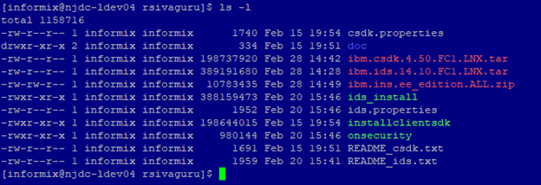

Note that the edition related file ibm.ins.ee_edition.ALL.zip is still in zipped / packed form. We have not yet unpacked it. We will go ahead and run the program “ids_install”. For brevity, we will not walk through the detailed licensing terms but will show important / relevant screen shots as necessary. As always, the installation should be run as user “root”. For non-root installations run the “ids_install” as non-root user.  
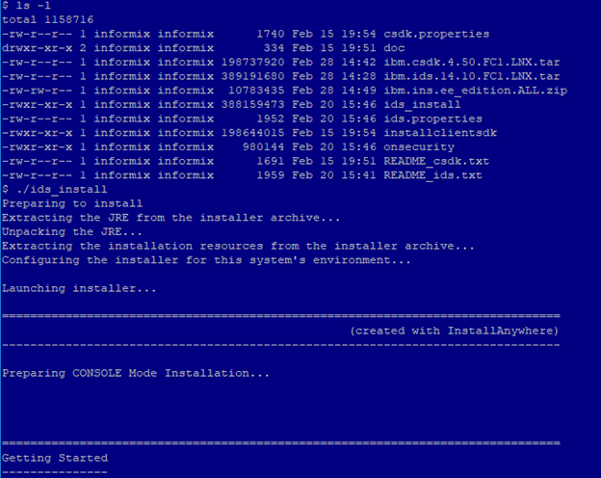

The program prompts for user input a few times and notably would make sure of the installation location (typically it is the location as per INFORMIXDIR environment variable). One other notable user input required determines if an instance is configured as part of the installation process. We have chosen not to configure and start an IBM Informix instance as shown in the screen shot below: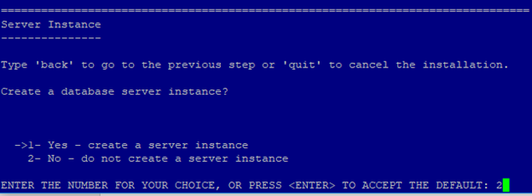

After this step you accept the installation items and confirm the installation and then the program goes about installing the software binaries based on the user input.

The installation is completed when you see the following:  
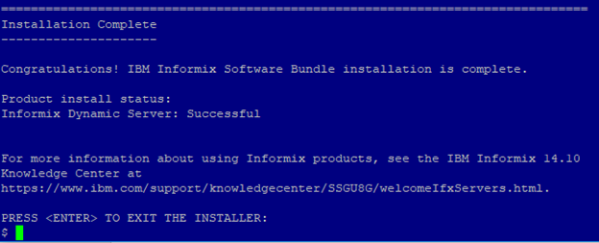

Notice that the only component that got installed is Informix Dynamic Server. Client Software Development Kit was not installed as a default. We should use the “installclientsdk” program to install CSDK.

Let us see what edition of IBM Informix 14.10 got installed. To find out, we can invoke the “oninit” command with the “-version” flag to find out details about the edition that was installed. The binary “oninit” is found in the bin directory where the product was installed.  
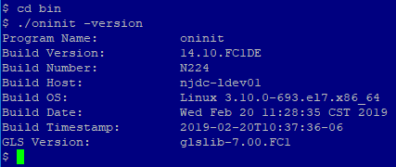

The Build Version is reported as 14.10.FC1DE. That is the Developer Edition. For production environments using this edition will severely limit the performance of the database server. You need to install the appropriate edition that your organization is entitled to. To do that follow the steps shown below.

Unpack the zip file that was downloaded along with the product from IBM’s Passport Advantage website. This file is named ibm.ins.ee_edition.ALL.zip (We are assuming here that your organization is entitled for Enterprise Edition of IBM Informix 14.10 Software). Unpack the zip file using the unzip command.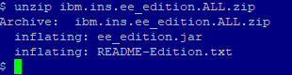

Two files were unpacked.

It is always a good idea to read the README-Edition.txt file. This file will share information about how to invoke the edition installer and make sure you have the right product installed.

Let’s now install the Enterprise Edition.  
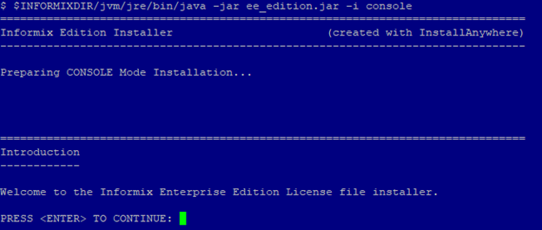

Invoke the edition installation by using the bundled java program. The jar file to use in this example is ee_edition.jar and we have chosen to install using the console mode.

As usual, you are prompted for user input a couple of times. The edition installer program will also prompt for the install location of the IBM Informix 14.10 binaries. Type in the exact location as it applies to your environment. The default location will be /opt/IBM/Informix. Make sure you take note of this and provide input as to the correct location as it applies for your installation.

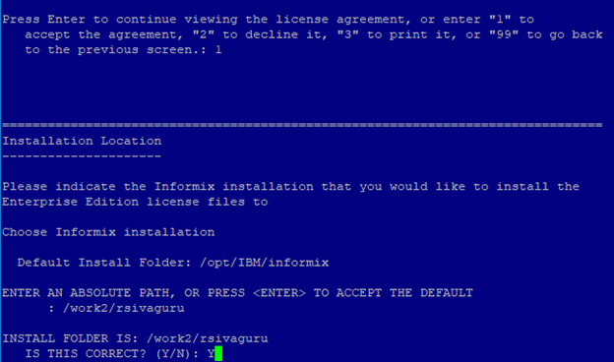

More user input / confirmation of installation summary….  
  
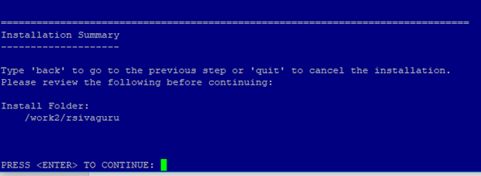

This ensures that the edition related changes have been installed by the edition installer program.  
  
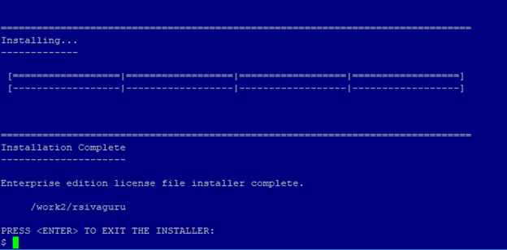

After the conclusion of the edition installation program, let us check the edition installed. Note that previously we installed the Developer Edition. Now the value shown for “Build Version” is 14.10.FC1. This implies that Enterprise Edition has now been installed in lieu of Developer Edition.  
  
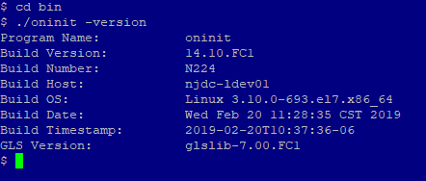

One thing to note here is that if your organization chooses to upgrade to the Advanced Enterprise Edition, all you should do is to shut down the database engine and obtain and unpack the edition installation jar file (the zip file for Advanced Enterprise Edition) and run the edition installation program to upgrade the edition and restart the database engine. It is that simple. The edition installation program is available as a zip file in the IBM Passport Advantage website. If for some reason you are not able to find the right edition entitlements, please contact your IBM Sales Representative.  
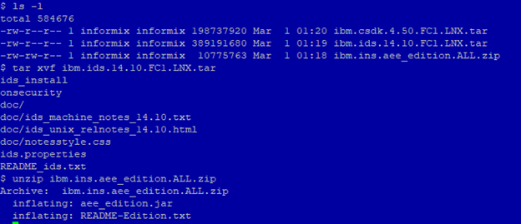

**Single Step Installation (aka Concurrent Installation)**

 Now let us go over the installation process as a single step or concurrent installation wherein we will unpack the edition installation jar files and run the “ids_install” program which will install the IBM Informix 14.10 software binaries and continue with the edition installation process and complete the entire installation in a single step. For this blog, we will show an example of installing Advanced Enterprise Edition and include the screen shots as well.

First, we unpack the IBM Informix 14.10 software using the tar command. Next, we unpack the Advanced Enterprise Edition zip file using the unzip command.



After unpacking the contents of the directory are as shown below:  
  
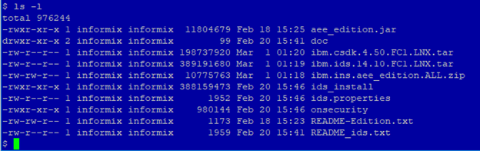

Notice that we now have the “ids_install” program and the Advanced Enterprise Edition jar file aee_edition.jar. We are now ready to install the IBM Informix 14.10 software and the edition that will be installed is Advanced Enterprise Edition.

We will invoke the “ids_install” program to install the software and the right edition. Note that we will only run the “ids_install” program and prior to issuing the “ids_install” command, we set the INFORMIXDIR environment variable.  
  
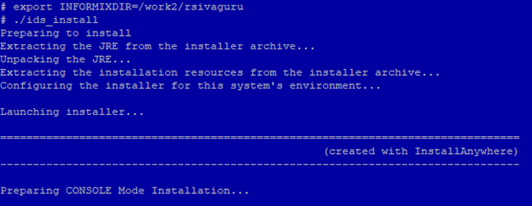

We will provide all the necessary user input to continue with the installation.  
  
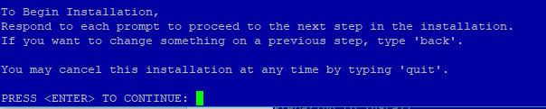

Continue with the installation by accepting the license terms and conditions. We type 1 to accept the license agreement.  
  
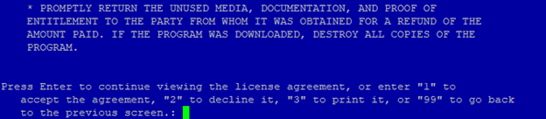

Accept the default installation folder (in our example it is /work2/rsivaguru directory). Hit Enter.  
  
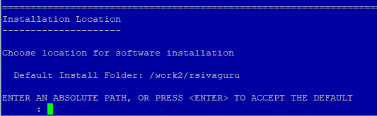

Moving along we choose to perform a Typical Installation.  
  
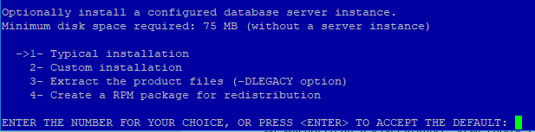

We will not create a server instance. We choose 2 now to just install the software binaries for IBM Informix 14.10 Advanced Enterprise Edition.  
  
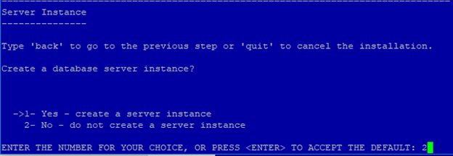

Hit Enter to continue with the installation. And once more hit Enter…  
  
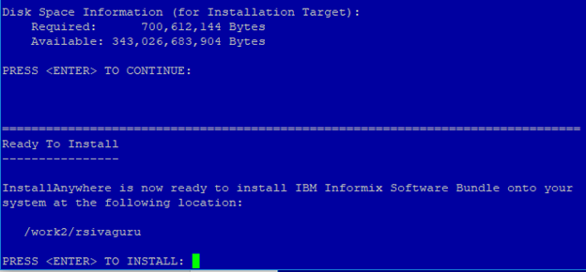  
After a couple of minutes, you should see that the installation complete to a success.  
  
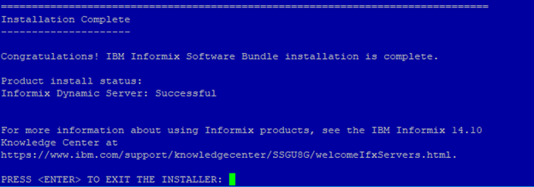

Hit enter to close out the “ids_install” program.

Now let us see the edition that got installed by the “ids_install” program. We will use the oninit program to check its version details.  
  
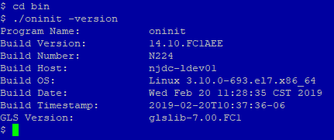

Voila!!! We have successfully installed the IBM Informix 14.10 Advanced Enterprise Edition. This is deciphered from the value for the Build Version which is shown as 14.10.FC1AEE.

By having the edition jar file aee_edition.jar unpacked, we could install the IBM 14.10.FC1 Advanced Enterprise Edition by just executing the “ids_install” program.

Please take note that we have only installed the IBM Informix 14.10 software and its binaries. The Client Software Development Kit (CSDK) is not installed by default. In the previous versions CSDK software could be installed by the “ids_install” program. With IBM Informix 14.10 release that is not the case. You should install CSDK software as a separate installation process.

Further it is always recommended to examine the log files just to make sure that there were no errors. The log files are named with product name and with date and time stamp as part of the file name. The format is IBM_Informix_14.10_Install_MM_DD_YYYY_HH_MM_SS.log and IBM_Informix_Software_Bundle_Install_MM_DD_YYYY_HH_MM_SS.log

**Installing CSDK software**

Prior to installing CSDK software, we should unpack the installation files using tar.  


The files that get unpacked are as per the screen shot below:  
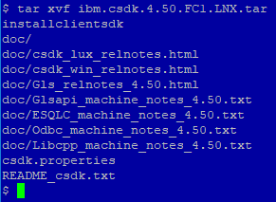  
 Next, we will use the “installclientsdk” program to install CSDK software.  
  
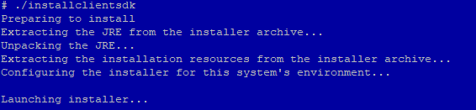

Provide user input as the program “installclientsdk” demands and continue with the installation.  
  
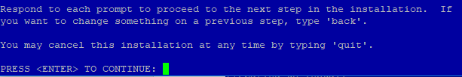

Enter 1 to accept the license terms and conditions.  
  
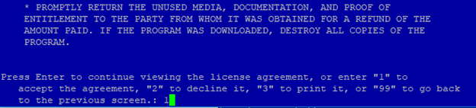

Either accept the default installation location or type in the directory where you want to install the CSDK software. We will accept the default location (shown as /work2/rsivaguru in our case).  
  
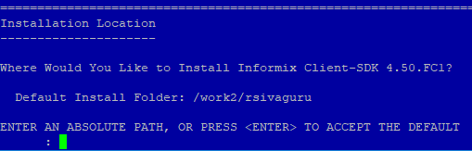

Next. You will see the default selections chosen for this install. You can choose to install the defaults or make appropriate selections. In our example, we will choose the defaults and press Enter.  
  
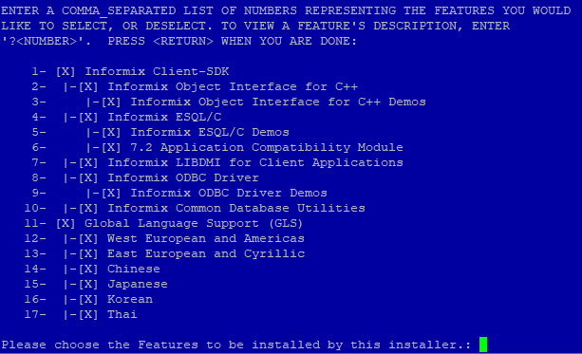

Provide input to accept the installation summary.  
  
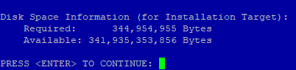

In a minute or two all the required files for the CSDK software will be installed taking into consideration of the input provided to select the components that were required to be installed. You should see a success message as shown below:  
  
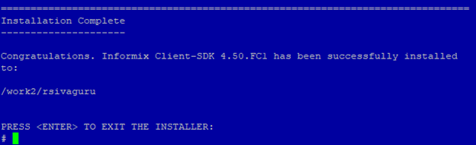

Complete the installation process by hitting Enter and this will exit the “installclientsdk” program.

This concludes the installation of Client Software Development Kit (CSDK) software.